
www.science-teachers.com/life.htm

Across
1 A conifer that does not produce a cone, but instead produces berry-like cups. It’s known for its hard wood (3)
5 The property of producing male and female trees like in Ginkgo trees. (9)
7 What gymnosperm means. (5,4)
10 A gymnosperm with cones. The name means 'cone bearing'. (7)
11 A conifer, cycad, or ginkgo tree. (10)
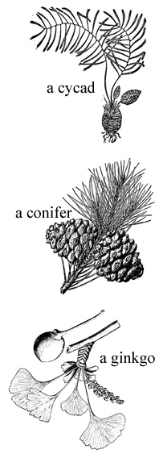
Down
2 The agent of pollination for conifers. (4)
3 A type of conifer tree. (4)
4 A common named used to describe the ginkgo trees. (10,4)
6 The number of ginkgo species left today. (3)
8 A palm-like gymnosperm. (5)
9 A gymnosperm that was preserved in the gardens of Buddhist monasteries. (6)

