

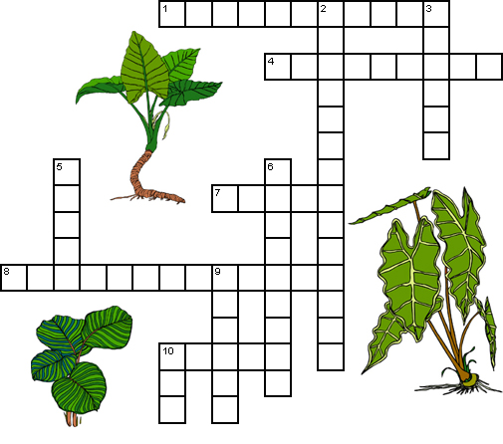
Across  1 A plant pigment that absorbs sunlight. (11)  4 The links between the energy that carnivores get from eating to the energy captured by photosynthesis. (4,5)  7 Chlorophyll absorbs every color of sunlight except this. (5)  8 A compound needed for photosynthesis. (6,7)  10 The product of photosynthesis. (5) | Down  2 The process by which plants and some bacteria use the energy from sunlight to produce sugar. (14)  3 Part of the plant where photosynthesis generally occurs. (6)  5 A compound needed for photosynthesis. (5)  6 An animal that eats plants. (9)  9 A by-product of photosynthesis. (6)  10 Number of molecules of oxygen produced along with one molecule of sugar. (3)

