Acids, Bases, and Salts Cloze
Fill in the blanks with words from the box.
cancel | crystals | dissolve |  | hydrochloric
ions | melting | metals |  | neutralization
nonmetals | sodium hydroxide | table salt |  | water
_________________ is a strong acid which can be used to clean rust off of steel. _________________, commonly known as lye, is a highly caustic base that is used to make soap. Both of these substances can cause severe burns if they come in contact with human skin. However, when these two very dangerous substances combine, they form _________________ and _________________, both of which are completely harmless.
This process of combining acids and bases to make salts and water is known as _________________. In this reaction, the acid and base _________________ each other out.
There are many different kinds of salts. In general, a salt is a compound of positive and negative _________________. Often the positive ions are _________________ such as sodium and the negative ions are _________________ such as chlorine.
In the absence of water, these ions can form _________________ which have a high _________________ point and are brittle. Many salts _________________ readily in water. |  |  | 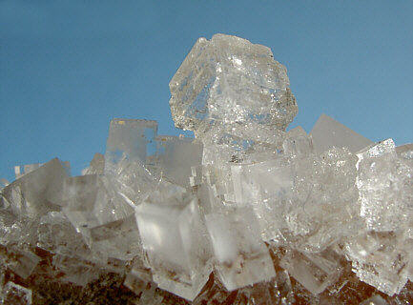  Sodium chloride crystals, commonly known as table salt.

